**Summary Report on MiPA General Meeting—September 13, 2022**

**30 Participating on Zoom**

**Trade Book Reviews: A Strategic Discussion**

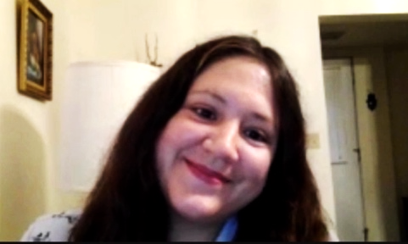

Tonight’s meeting covered trade book reviews (all review outlets), and was led by Michelle Schingler, editor of [***Foreword Reviews***](https://Mipa.us16.list-manage.com/track/click?u=f0dd55973a9c4348b9b43ad7c&id=6ed497a697&e=d34ebc8a8f).

Michelle described the different types of reviews, the timing with submissions, what to submit, how to use them for maximum benefit, and the value they add to your business.

**Pre-meeting discussion:**

Alert! Several people described scams they have recently experienced where someone unknown offered to buy 10,000 books or more, but where the payment was unclear. Delete these.

Jennifer Baum, MiPA’s Executive Director then introduce the MiPA Board and described several upcoming events:

* On October 11 at 7p.m. Central, our monthly meeting will be led by Kristen Noland, on the subject of ***Editing***.
* On October 20 at 12 p.m. Central, Carol Topp, CPA, will discuss ***Taxes for Writers and Publishers***. There is a $10 fee for this meeting, but you will receive a PDF copy of her very useful book.
* ***Lunch & Learn*** November 16 or 17, 12 p.m. Central, for an informal discussion with lawyer David Koehser. Have your questions ready.
* ***MiPA Book Catalog*** will be available by October. 12 for the Heartland Fall Forum and distributed to 200+ indie Midwest booksellers later. Send in your titles at $25 each, by September 28. Midwest Book Award winners are included for free. The new Midwest Book Award competition is now open for 2022 books.

**Michelle’s talk:**

Trade reviews and consumer reviews target different audiences. Trade reviews are targeting libraries and booksellers in advance of publication, hopefully for bulk orders. They try to provide reliable honest opinions about how a book measures up to its peers. They also assess trends that will be helpful to booksellers and libraries. Foreward Reviews can include up to 118 newbie authors as well as ones who are well established. Here are some of the top trade reviewers

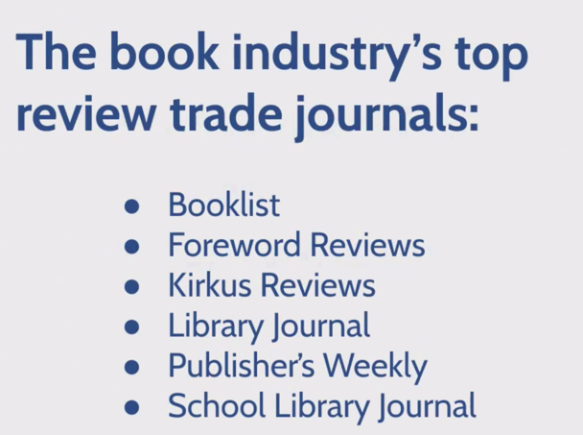

**What is in it for publishers:**

Recognition from a trusted source. They get the book’s summary and purpose out there. The review provides possible information for a blurb, cover, or jacket, as well as a possible uptick in sales.

**How to send the book in:**

Ideally it should be in 4.5 months before publication. Sending an ARC is okay, but make it as good as possible. Digital copies are generally fine as a PDF. Send a tip sheet with all the key information. The follow up about the review status varies between reviewer companies. Foreward Reviews doesn’t track the status well. PR agencies can be helpful keeping all the requirements and dates straight, but they are not required.

**What trade journals are looking for:**

Ideally the book should be well written and professionally packaged. Foreward Reviews looks for author expertise, innovative ideas, and something others are not covering. They get 1,200 books per month. An eye-catching tip sheet is important (see next page for an example).

**Fee for review service options:**

Paid reviews are no longer treated with suspicion and are offered by most journals. Foreword Reviews are generally longer than reviews from many other companies and are syndicated to many wholesalers.

**General advice:**

Invest in cover art, interior design, and expert editorial assistance. Do your homework about the trade journals. A succinct and professional tip sheet is valuable. Don’t rush the process.

Here is an example of a good tip sheet:



**Email questions are welcome:**

mschingler@forewordreviews.com

Foreword Review submission guidelines: www.forewordreviews.com

Q1. Can one submit prior to typesetting?

A1. Yes, more for fiction than non-fiction.

Q2. Explain what syndicated to the wholesalers means.

A2. Our reviews flow every two weeks, or each month, into the database of buyers. This is important for unknown authors especially.

Q3. Is my book coming out in November too late?

A3. Most buyers would like more lead time. It costs $499 for a review. We don’t want our readers to rush, 4-6 weeks for them is typical.

Q4. How often are books chosen for review?

A4. The fee for review guarantees a review. You get a chance to see the review before it goes out, and reject it if you like. If you just submit for the magazine, only about 10% are accepted for review. Reviews stay on the website forever.

Q5. How do you make sense of 1,200 books per month?

A5. It’s just a lot of winnowing. We have about 50 active readers.

Q6. How big is your circulation?

A6. I believe our circulation is about 30,000 now.

Q7. What does it mean to get a **Star** review?

A7. It means it was something we were excited about.

Q8. Are any trends fading?

A8. The magical school books are getting weaker.

Q9. Can the pay for review option work for books already released?

A9. Yes.

Q10. The types of books you are interested in is listed on your website, right?

A10. Yes.

Q11. What is the ratio of fiction to non-fiction you see?

A11. We receive more fiction.

Q12. How do you deal with different genres or segments?

A12. We just look for good books, and don’t worry much about the marketing.

Q13. How does it feel if you see a lot of typos, etc. for an ARC?

A13. We are critiquing what a book will become. If is already published we are a less forgiving. Don’t send us partials.

Q14. Tell us about your email marketing.

A15. We try keep that part separate from the reviews. Jennifer has liked these in her experience.